|  |  |  |  |  |  |  |  |  |  |  |  |
| --- | --- | --- | --- | --- | --- | --- | --- | --- | --- | --- | --- |
|  |  |  |  |  |  |  |  |  |  |  |  |
|  |  | | | **Protokół zmiany schematu oraz projektu płytki obsługującej czujnik US** | | | | | | Data wystawienia: | |
|  |  | |
|  | Doc# |  |
|  | Nr wniosku NCBR: | | POIR.01.01.01-00-0196/19 | | | Nazwa projektu: | | Smart Yacht |
|  | Rozpoczęcie testów: | |  | | Zakończenie testów: | |  | |

#### Założenia

Podczas montażu systemu prototypowego został zaobserwowany szereg problemów:

1. Błędy w komunikacji UART podczas adresowania czujników ultradźwiękowych

2. Problematyczny montaż systemu spowodowany obecnością dużej ilości linii w przewodzie

3. Problematyczny montaż mechaniczny modułu czujnika US

4. Problematyczny i powolny sposób montazu przewodów

5. Nieustalony standard dotyczący złącz- wymagał zastosowania wielu przejściówek

6. Nieuzasadnione zwiększenie kosztów poprzez projekt obwodu 4 warstwowego.

7. Problematyczne programowanie układu(wymagane zasilanie 12V)

Postanowiono zmodyfikować schemat, a co za tym idzie przeprojektować obwód drukowany.

#### **Zmiany wprowadzone w schemacie**

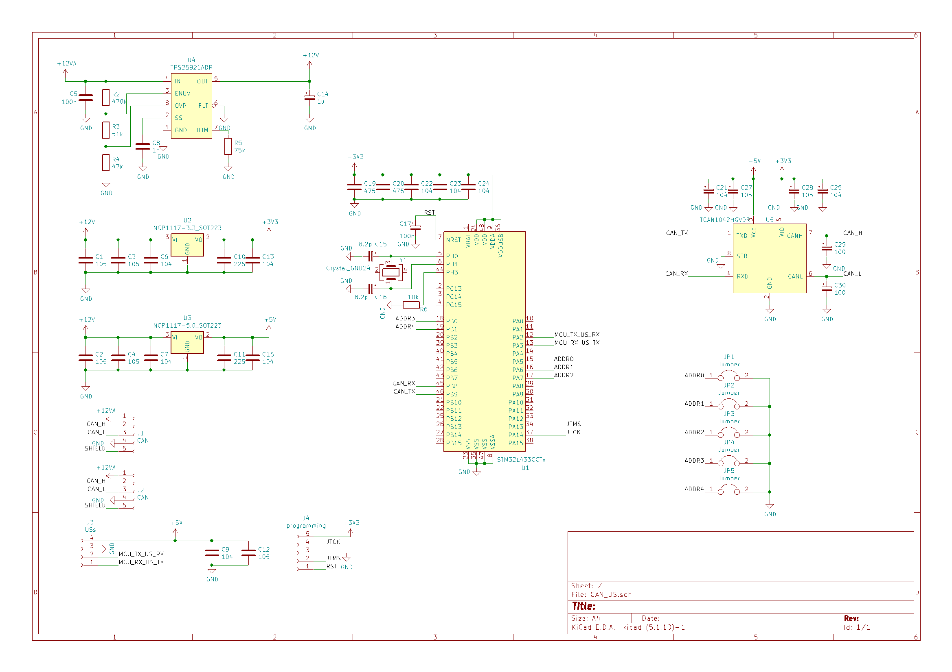Figura 1: Nowy schemat sterownika czujnika US

-Zmiana złącza CAN z 8 na 5 pinowe

-Dodane zwory umożliwiające indywidualne przypisanie adresu każdemu z czujników

-Kondensatory tantalowe zostały wymieniona na MLCC

-złącze czujnika US zostało wymienione na 4 pinowe umożliwia to podłączenia czujnika oryginalną złączką.

-Dodano oddzielne złącze do programowania układu, wyposażone w pin RESET.

#### Zmiany wprowadzone w projekcie PCB

Płytka PCB została w całości zaprojektowana od nowa, na 2 warstwach miedzi.

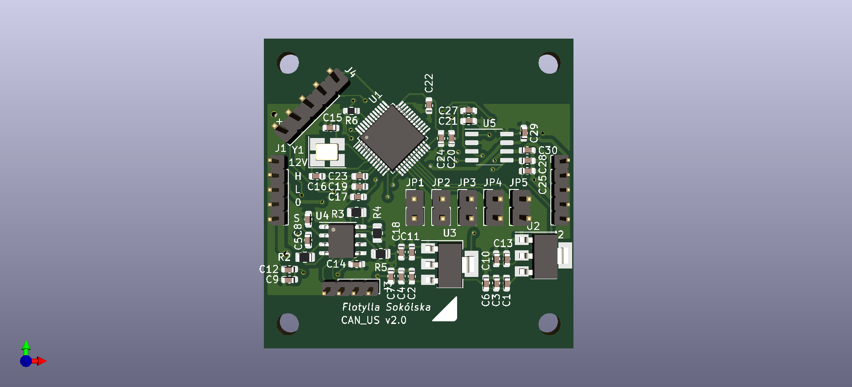Figura 2: Płytka sterownika US, wersja 2.0

Widoczne 5-pinowe złącza can na lewej oraz prawej krawędzi, złącze programowania w lewym górnym rogu oraz złącze czujnika US na dole.

Wymiary płytki i rozstaw otworów pozostają bez zmian.

#### **Zmiany wprowadzone w programie**

Treść pliku głównego:

/* USER CODE BEGIN Header */

/**

******************************************************************************

* @file : main.c

* @brief : Main program body

******************************************************************************

* @attention

*

* <h2><center>&copy; Copyright (c) 2021 STMicroelectronics.

* All rights reserved.</center></h2>

*

* This software component is licensed by ST under BSD 3-Clause license,

* the "License"; You may not use this file except in compliance with the

* License. You may obtain a copy of the License at:

* opensource.org/licenses/BSD-3-Clause

*

******************************************************************************

*/

/* USER CODE END Header */

/* Includes ------------------------------------------------------------------*/

**#include** "main.h"

/* Private includes ----------------------------------------------------------*/

/* USER CODE BEGIN Includes */

/* USER CODE END Includes */

/* Private typedef -----------------------------------------------------------*/

/* USER CODE BEGIN PTD */

/* USER CODE END PTD */

/* Private define ------------------------------------------------------------*/

/* USER CODE BEGIN PD */

/* USER CODE END PD */

/* Private macro -------------------------------------------------------------*/

/* USER CODE BEGIN PM */

/* USER CODE END PM */

/* Private variables ---------------------------------------------------------*/

CAN_HandleTypeDef hcan1;

TIM_HandleTypeDef htim6;

UART_HandleTypeDef huart1;

UART_HandleTypeDef huart2;

UART_HandleTypeDef huart3;

/* USER CODE BEGIN PV */

/* USER CODE END PV */

/* Private function prototypes -----------------------------------------------*/

**void** SystemClock_Config(**void**);

**static** **void** MX_GPIO_Init(**void**);

**static** **void** MX_CAN1_Init(**void**);

**static** **void** MX_USART1_UART_Init(**void**);

**static** **void** MX_USART2_UART_Init(**void**);

**static** **void** MX_USART3_UART_Init(**void**);

**static** **void** MX_TIM6_Init(**void**);

/* USER CODE BEGIN PFP */

**void** setCanAdress(**void**);

/* USER CODE END PFP */

/* Private user code ---------------------------------------------------------*/

/* USER CODE BEGIN 0 */

/* USER CODE END 0 */

/**

* @brief The application entry point.

* @retval int

*/

**int** main(**void**)

{

/* USER CODE BEGIN 1 */

/* USER CODE END 1 */

/* MCU Configuration--------------------------------------------------------*/

/* Reset of all peripherals, Initializes the Flash interface and the Systick. */

HAL_Init();

/* USER CODE BEGIN Init */

/* USER CODE END Init */

/* Configure the system clock */

SystemClock_Config();

/* USER CODE BEGIN SysInit */

/* USER CODE END SysInit */

/* Initialize all configured peripherals */

MX_GPIO_Init();

MX_CAN1_Init();

MX_USART1_UART_Init();

MX_USART2_UART_Init();

MX_USART3_UART_Init();

MX_TIM6_Init();

/* USER CODE BEGIN 2 */

HAL_UART_Init(&huart2);

HAL_HalfDuplex_Init(&huart1);

HAL_HalfDuplex_Init(&huart3);

HAL_HalfDuplex_EnableReceiver(&huart1);

HAL_HalfDuplex_EnableReceiver(&huart3);

HAL_UART_Receive_IT(&huart2, &uartUsRx, 1);

HAL_UART_Receive_IT(&huart3, uart1WireRx, 2);

HAL_UART_Receive_IT(&huart1, uart1WireRx, 2);

HAL_FLASHEx_OBGetConfig(&pOB);

HAL_CAN_Init(&hcan1);

HAL_CAN_Start(&hcan1);

uartState = reciving;

//HAL_IWDG_Init(&hiwdg);

/*if(FLASH_OPTR_nBOOT1 & pOB.USERConfig ||FLASH_OPTR_nBOOT0 & pOB.USERConfig || FLASH_OPTR_nSWBOOT0 & pOB.USERConfig){

setBootFromSRAM(&pOB);

}

setBootFromSRAM(&pOB);*/

bootloader_Init(&hcan1, &TxMailbox, 25);

canId = 200;

HAL_TIM_Base_Start_IT(&htim6);

setCanAdress();

/* USER CODE END 2 */

/* Infinite loop */

/* USER CODE BEGIN WHILE */

**while** (1) {

/* USER CODE END WHILE */

/* USER CODE BEGIN 3 */

}

/* USER CODE END 3 */

}

/**

* @brief System Clock Configuration

* @retval None

*/

**void** SystemClock_Config(**void**)

{

RCC_OscInitTypeDef RCC_OscInitStruct = {0};

RCC_ClkInitTypeDef RCC_ClkInitStruct = {0};

RCC_PeriphCLKInitTypeDef PeriphClkInit = {0};

/** Initializes the RCC Oscillators according to the specified parameters

* in the RCC_OscInitTypeDef structure.

*/

RCC_OscInitStruct.OscillatorType = RCC_OSCILLATORTYPE_HSE;

RCC_OscInitStruct.HSEState = RCC_HSE_ON;

RCC_OscInitStruct.PLL.PLLState = RCC_PLL_ON;

RCC_OscInitStruct.PLL.PLLSource = RCC_PLLSOURCE_HSE;

RCC_OscInitStruct.PLL.PLLM = 1;

RCC_OscInitStruct.PLL.PLLN = 20;

RCC_OscInitStruct.PLL.PLLP = RCC_PLLP_DIV7;

RCC_OscInitStruct.PLL.PLLQ = RCC_PLLQ_DIV2;

RCC_OscInitStruct.PLL.PLLR = RCC_PLLR_DIV2;

**if** (HAL_RCC_OscConfig(&RCC_OscInitStruct) != HAL_OK)

{

Error_Handler();

}

/** Initializes the CPU, AHB and APB buses clocks

*/

RCC_ClkInitStruct.ClockType = RCC_CLOCKTYPE_HCLK|RCC_CLOCKTYPE_SYSCLK

|RCC_CLOCKTYPE_PCLK1|RCC_CLOCKTYPE_PCLK2;

RCC_ClkInitStruct.SYSCLKSource = RCC_SYSCLKSOURCE_PLLCLK;

RCC_ClkInitStruct.AHBCLKDivider = RCC_SYSCLK_DIV1;

RCC_ClkInitStruct.APB1CLKDivider = RCC_HCLK_DIV1;

RCC_ClkInitStruct.APB2CLKDivider = RCC_HCLK_DIV1;

**if** (HAL_RCC_ClockConfig(&RCC_ClkInitStruct, FLASH_LATENCY_4) != HAL_OK)

{

Error_Handler();

}

PeriphClkInit.PeriphClockSelection = RCC_PERIPHCLK_USART1|RCC_PERIPHCLK_USART2

|RCC_PERIPHCLK_USART3;

PeriphClkInit.Usart1ClockSelection = RCC_USART1CLKSOURCE_PCLK2;

PeriphClkInit.Usart2ClockSelection = RCC_USART2CLKSOURCE_PCLK1;

PeriphClkInit.Usart3ClockSelection = RCC_USART3CLKSOURCE_PCLK1;

**if** (HAL_RCCEx_PeriphCLKConfig(&PeriphClkInit) != HAL_OK)

{

Error_Handler();

}

/** Configure the main internal regulator output voltage

*/

**if** (HAL_PWREx_ControlVoltageScaling(PWR_REGULATOR_VOLTAGE_SCALE1) != HAL_OK)

{

Error_Handler();

}

}

/**

* @brief CAN1 Initialization Function

* @param None

* @retval None

*/

**static** **void** MX_CAN1_Init(**void**)

{

/* USER CODE BEGIN CAN1_Init 0 */

/* USER CODE END CAN1_Init 0 */

/* USER CODE BEGIN CAN1_Init 1 */

/* USER CODE END CAN1_Init 1 */

hcan1.Instance = CAN1;

hcan1.Init.Prescaler = 40;

hcan1.Init.Mode = CAN_MODE_NORMAL;

hcan1.Init.SyncJumpWidth = CAN_SJW_1TQ;

hcan1.Init.TimeSeg1 = CAN_BS1_13TQ;

hcan1.Init.TimeSeg2 = CAN_BS2_2TQ;

hcan1.Init.TimeTriggeredMode = DISABLE;

hcan1.Init.AutoBusOff = DISABLE;

hcan1.Init.AutoWakeUp = ENABLE;

hcan1.Init.AutoRetransmission = ENABLE;

hcan1.Init.ReceiveFifoLocked = DISABLE;

hcan1.Init.TransmitFifoPriority = DISABLE;

**if** (HAL_CAN_Init(&hcan1) != HAL_OK)

{

Error_Handler();

}

/* USER CODE BEGIN CAN1_Init 2 */

canFilterConfig.FilterMode = CAN_FILTERMODE_IDMASK;

canFilterConfig.FilterScale = CAN_FILTERSCALE_32BIT;

canFilterConfig.FilterIdHigh = 210;

canFilterConfig.FilterIdLow = 200;

canFilterConfig.FilterMaskIdHigh = 0x0000;

canFilterConfig.FilterMaskIdLow = 0x0000;

canFilterConfig.FilterFIFOAssignment = CAN_RX_FIFO0;

canFilterConfig.FilterActivation = ENABLE;

canFilterConfig.FilterBank = 1;

HAL_CAN_ConfigFilter(&hcan1, &canFilterConfig);

canFilterConfig.FilterIdHigh = 0;

canFilterConfig.FilterIdLow = 0;

canFilterConfig.FilterBank = 2;

HAL_CAN_ConfigFilter(&hcan1, &canFilterConfig);

HAL_CAN_Start(&hcan1);

**if** (HAL_CAN_ActivateNotification(&hcan1, CAN_IT_RX_FIFO0_MSG_PENDING)

!= HAL_OK) {

/* Notification Error */

Error_Handler();

}

canTxHeader.DLC = 1; //give message size of 1 byte

canTxHeader.IDE = CAN_ID_STD; //set identifier to standard

canTxHeader.RTR = CAN_RTR_DATA; //set data type to remote transmission request?

canTxHeader.StdId = 200;

canTxHeader.ExtId = 0x00;

/* USER CODE END CAN1_Init 2 */

}

/**

* @brief TIM6 Initialization Function

* @param None

* @retval None

*/

**static** **void** MX_TIM6_Init(**void**)

{

/* USER CODE BEGIN TIM6_Init 0 */

/* USER CODE END TIM6_Init 0 */

TIM_MasterConfigTypeDef sMasterConfig = {0};

/* USER CODE BEGIN TIM6_Init 1 */

/* USER CODE END TIM6_Init 1 */

htim6.Instance = TIM6;

htim6.Init.Prescaler = 2999;

htim6.Init.CounterMode = TIM_COUNTERMODE_UP;

htim6.Init.Period = 2665;

htim6.Init.AutoReloadPreload = TIM_AUTORELOAD_PRELOAD_DISABLE;

**if** (HAL_TIM_Base_Init(&htim6) != HAL_OK)

{

Error_Handler();

}

sMasterConfig.MasterOutputTrigger = TIM_TRGO_RESET;

sMasterConfig.MasterSlaveMode = TIM_MASTERSLAVEMODE_DISABLE;

**if** (HAL_TIMEx_MasterConfigSynchronization(&htim6, &sMasterConfig) != HAL_OK)

{

Error_Handler();

}

/* USER CODE BEGIN TIM6_Init 2 */

/* USER CODE END TIM6_Init 2 */

}

/**

* @brief USART1 Initialization Function

* @param None

* @retval None

*/

**static** **void** MX_USART1_UART_Init(**void**)

{

/* USER CODE BEGIN USART1_Init 0 */

/* USER CODE END USART1_Init 0 */

/* USER CODE BEGIN USART1_Init 1 */

/* USER CODE END USART1_Init 1 */

huart1.Instance = USART1;

huart1.Init.BaudRate = 9600;

huart1.Init.WordLength = UART_WORDLENGTH_9B;

huart1.Init.StopBits = UART_STOPBITS_1;

huart1.Init.Parity = UART_PARITY_EVEN;

huart1.Init.Mode = UART_MODE_TX_RX;

huart1.Init.HwFlowCtl = UART_HWCONTROL_NONE;

huart1.Init.OverSampling = UART_OVERSAMPLING_16;

huart1.Init.OneBitSampling = UART_ONE_BIT_SAMPLE_DISABLE;

huart1.AdvancedInit.AdvFeatureInit = UART_ADVFEATURE_NO_INIT;

**if** (HAL_HalfDuplex_Init(&huart1) != HAL_OK)

{

Error_Handler();

}

/* USER CODE BEGIN USART1_Init 2 */

/* USER CODE END USART1_Init 2 */

}

/**

* @brief USART2 Initialization Function

* @param None

* @retval None

*/

**static** **void** MX_USART2_UART_Init(**void**)

{

/* USER CODE BEGIN USART2_Init 0 */

/* USER CODE END USART2_Init 0 */

/* USER CODE BEGIN USART2_Init 1 */

/* USER CODE END USART2_Init 1 */

huart2.Instance = USART2;

huart2.Init.BaudRate = 9600;

huart2.Init.WordLength = UART_WORDLENGTH_8B;

huart2.Init.StopBits = UART_STOPBITS_1;

huart2.Init.Parity = UART_PARITY_NONE;

huart2.Init.Mode = UART_MODE_RX;

huart2.Init.HwFlowCtl = UART_HWCONTROL_NONE;

huart2.Init.OverSampling = UART_OVERSAMPLING_16;

huart2.Init.OneBitSampling = UART_ONE_BIT_SAMPLE_DISABLE;

huart2.AdvancedInit.AdvFeatureInit = UART_ADVFEATURE_NO_INIT;

**if** (HAL_UART_Init(&huart2) != HAL_OK)

{

Error_Handler();

}

/* USER CODE BEGIN USART2_Init 2 */

/* USER CODE END USART2_Init 2 */

}

/**

* @brief USART3 Initialization Function

* @param None

* @retval None

*/

**static** **void** MX_USART3_UART_Init(**void**)

{

/* USER CODE BEGIN USART3_Init 0 */

/* USER CODE END USART3_Init 0 */

/* USER CODE BEGIN USART3_Init 1 */

/* USER CODE END USART3_Init 1 */

huart3.Instance = USART3;

huart3.Init.BaudRate = 9600;

huart3.Init.WordLength = UART_WORDLENGTH_9B;

huart3.Init.StopBits = UART_STOPBITS_1;

huart3.Init.Parity = UART_PARITY_EVEN;

huart3.Init.Mode = UART_MODE_TX_RX;

huart3.Init.HwFlowCtl = UART_HWCONTROL_NONE;

huart3.Init.OverSampling = UART_OVERSAMPLING_16;

huart3.Init.OneBitSampling = UART_ONE_BIT_SAMPLE_DISABLE;

huart3.AdvancedInit.AdvFeatureInit = UART_ADVFEATURE_NO_INIT;

**if** (HAL_HalfDuplex_Init(&huart3) != HAL_OK)

{

Error_Handler();

}

/* USER CODE BEGIN USART3_Init 2 */

/* USER CODE END USART3_Init 2 */

}

/**

* @brief GPIO Initialization Function

* @param None

* @retval None

*/

**static** **void** MX_GPIO_Init(**void**)

{

GPIO_InitTypeDef GPIO_InitStruct = {0};

/* GPIO Ports Clock Enable */

__HAL_RCC_GPIOC_CLK_ENABLE();

__HAL_RCC_GPIOH_CLK_ENABLE();

__HAL_RCC_GPIOA_CLK_ENABLE();

__HAL_RCC_GPIOB_CLK_ENABLE();

/*Configure GPIO pins : ADDR0_Pin ADDR1_Pin ADDR2_Pin */

GPIO_InitStruct.Pin = ADDR0_Pin|ADDR1_Pin|ADDR2_Pin;

GPIO_InitStruct.Mode = GPIO_MODE_INPUT;

GPIO_InitStruct.Pull = GPIO_PULLUP;

HAL_GPIO_Init(GPIOA, &GPIO_InitStruct);

/*Configure GPIO pins : ADDR3_Pin ADDR4_Pin */

GPIO_InitStruct.Pin = ADDR3_Pin|ADDR4_Pin;

GPIO_InitStruct.Mode = GPIO_MODE_INPUT;

GPIO_InitStruct.Pull = GPIO_PULLUP;

HAL_GPIO_Init(GPIOB, &GPIO_InitStruct);

}

/* USER CODE BEGIN 4 */

**void** setCanAdress(**void**) {

//od 200 co 10

//odczytaj zworki adresowe

uint8_t bit0 = HAL_GPIO_ReadPin(ADDR0_GPIO_Port, ADDR0_Pin);

uint8_t bit1 = HAL_GPIO_ReadPin(ADDR1_GPIO_Port, ADDR1_Pin);

uint8_t bit2 = HAL_GPIO_ReadPin(ADDR2_GPIO_Port, ADDR2_Pin);

uint8_t bit3 = HAL_GPIO_ReadPin(ADDR3_GPIO_Port, ADDR3_Pin);

uint8_t bit4 = HAL_GPIO_ReadPin(ADDR4_GPIO_Port, ADDR4_Pin);

**if** (bit0 == 1 && bit1 == 1 && bit2 == 1 && bit3 == 1 && bit4 == 1)

canId = 1010;

**else** **if**(bit0 == 1 && bit1 == 1 && bit2 == 1 && bit3 == 1 && bit4 == 0)

canId = 1020;

**else** **if**(bit0 == 1 && bit1 == 1 && bit2 == 1 && bit3 == 0 && bit4 == 1)

canId = 1030;

**else** **if**(bit0 == 1 && bit1 == 1 && bit2 == 1 && bit3 == 0 && bit4 == 0)

canId = 1040;

**else** **if**(bit0 == 1 && bit1 == 1 && bit2 == 0 && bit3 == 1 && bit4 == 1)

canId = 1050;

**else** **if**(bit0 == 1 && bit1 == 1 && bit2 == 0 && bit3 == 1 && bit4 == 0)

canId = 1060;

**else** **if**(bit0 == 1 && bit1 == 1 && bit2 == 0 && bit3 == 0 && bit4 == 1)

canId = 1070;

**else** **if**(bit0 == 1 && bit1 == 1 && bit2 == 0 && bit3 == 0 && bit4 == 0)

canId = 1080;

**else** **if**(bit0 == 1 && bit1 == 0 && bit2 == 1 && bit3 == 1 && bit4 == 1)

canId = 1090;

**else** **if**(bit0 == 1 && bit1 == 0 && bit2 == 1 && bit3 == 1 && bit4 == 0)

canId = 1100;

**else** **if**(bit0 == 1 && bit1 == 0 && bit2 == 1 && bit3 == 0 && bit4 == 1)

canId = 1110;

**else** **if**(bit0 == 1 && bit1 == 0 && bit2 == 1 && bit3 == 0 && bit4 == 0)

canId = 1120;

**else** **if**(bit0 == 1 && bit1 == 0 && bit2 == 0 && bit3 == 1 && bit4 == 1)

canId = 1130;

**else** **if**(bit0 == 1 && bit1 == 0 && bit2 == 0 && bit3 == 1 && bit4 == 0)

canId = 1140;

**else** **if**(bit0 == 1 && bit1 == 0 && bit2 == 0 && bit3 == 0 && bit4 == 1)

canId = 1150;

//ustaw adres czujnika

canTxHeader.StdId = canId;

}

//void HAL_CAN_RxFifo0MsgPendingCallback(CAN_HandleTypeDef *hcan) {

// //HAL_IWDG_Refresh(&hiwdg);

// HAL_CAN_GetRxMessage(hcan, CAN_RX_FIFO0, &canRxHeader, canRxData);

// switch (canRxHeader.StdId) { //komendy do bootloadera

// case 200: // włączenie bootloadera

// if (canRxData[0] == 1) {

// flags.programmingBusy = 1;

// }

// if (canRxData[0] == 0) {

// flags.programmingBusy = 0;

// }

// break;

// case 201: //wysłanie id

// canTxHeader.StdId = 200;

// canTxHeader.DLC = 3;

// canTxData[0] = (canId >> 8) & 0xFF;

// canTxData[1] = canId & 0xFF;

// canTxData[2] = 1;

// HAL_CAN_AddTxMessage(&hcan1, &canTxHeader, canTxData, &TxMailbox);

// break;

// case 202: //uruchomienie bootloadera

// if ((canRxData[0] << 8) + canRxData[1] == canId) {

// canTxHeader.DLC = 2;

// canTxHeader.IDE = 0;

// HAL_CAN_AddTxMessage(&hcan1, &canTxHeader, canRxData, &TxMailbox);

// startBootloader(&hcan1);

// }

// break;

// }

//}

**void** HAL_UART_RxCpltCallback(UART_HandleTypeDef *huart) {

//HAL_IWDG_Refresh(&hiwdg);

// if (huart == &huart1) {

// canAdressingProtocol(&canId, uart1WireRx, &huart1, &huart3, &uartState);

// }

// if (huart == &huart3) {

// canAdressingProtocol(&canId, uart1WireRx, &huart1, &huart3, &uartState);

// }

**if** (huart == &huart2) { //odczyt danych z czujnka

**if** (uartUsRx == 0xff || us.frameStarted == 0) { //&&

us.data[0] = uartUsRx;

us.counter = 0;

us.frameStarted = 1;

}

**if** (us.frameStarted == 1) {

us.data[us.counter] = uartUsRx;

**if** (us.counter == 3) {

us.frameStarted = 0;

**int** sum = (us.data[0] + us.data[1] + us.data[2]) & 0x00FF;

**if** (sum == us.data[3]) {

us.distance = (us.data[1] << 8) + us.data[2];

// if (us.distance < 280) {

// us.distance = 280;

// }

// if (us.distance > 7500) {

// us.distance = 7500;

// }

**if** (us.distance < 280 && us.distance >= 255) {

us.distance = 280;

}

**if** (us.distance > 7500 || us.distance <= 255) {

us.distance = 7500;

}

canTxHeader.StdId = canId;

canTxHeader.DLC = 2;

canTxData[0] = us.distance >> 8;

canTxData[1] = us.distance;

}

} **else** {

us.counter++;

}

}

HAL_UART_Receive_IT(&huart2, &uartUsRx, 1);

}

}

**void** HAL_TIM_PeriodElapsedCallback(TIM_HandleTypeDef *htim) {

**if** (htim->Instance == TIM6) {

HAL_CAN_AddTxMessage(&hcan1, &canTxHeader, canTxData, &TxMailbox);

}

}

**void** setBootFromSysMem(FLASH_OBProgramInitTypeDef *pOB) {

**if** (HAL_FLASH_Unlock() == HAL_OK) {

**if** (HAL_FLASH_OB_Unlock() == HAL_OK) {

pOB->OptionType = OPTIONBYTE_USER;

pOB->USERType = OB_USER_nBOOT1 | OB_USER_nSWBOOT0 | OB_USER_nBOOT0;

pOB->USERConfig = 0;

pOB->USERConfig = FLASH_OPTR_nBOOT1;

HAL_FLASHEx_OBProgram(pOB);

HAL_FLASH_OB_Launch();

}

HAL_FLASH_OB_Lock();

HAL_FLASH_Lock();

HAL_FLASH_OB_Launch();

}

}

**void** setBootFromSRAM(FLASH_OBProgramInitTypeDef *pOB) {

**if** (HAL_FLASH_Unlock() == HAL_OK) {

**if** (HAL_FLASH_OB_Unlock() == HAL_OK) {

pOB->OptionType = OPTIONBYTE_USER;

pOB->USERType = OB_USER_nBOOT1 | OB_USER_nSWBOOT0 | OB_USER_nBOOT0;

pOB->USERConfig = 0;

HAL_FLASHEx_OBProgram(pOB);

HAL_FLASH_OB_Launch();

}

HAL_FLASH_Lock();

HAL_FLASH_OB_Lock();

}

}

/* USER CODE END 4 */

/**

* @brief This function is executed in case of error occurrence.

* @retval None

*/

**void** Error_Handler(**void**)

{

/* USER CODE BEGIN Error_Handler_Debug */

/* User can add his own implementation to report the HAL error return state */

__disable_irq();

**while** (1) {

}

/* USER CODE END Error_Handler_Debug */

}

**#ifdef** USE_FULL_ASSERT

/**

* @brief Reports the name of the source file and the source line number

* where the assert_param error has occurred.

* @param file: pointer to the source file name

* @param line: assert_param error line source number

* @retval None

*/

**void** assert_failed(uint8_t *file, uint32_t line)

{

/* USER CODE BEGIN 6 */

/* User can add his own implementation to report the file name and line number,

ex: printf("Wrong parameters value: file %s on line %d\r\n", file, line) */

/* USER CODE END 6 */

}

**#endif** /* USE_FULL_ASSERT */

/************************ (C) COPYRIGHT STMicroelectronics *****END OF FILE****/

Usunięto protokół adresowania kontrolerów poprzez interfejs UART, dodano funkcję setCanAdress() ustawiającą adres CAN kontrolera przy pomocy zworek.

Odwrócono także zamianę pinów RX/TX w UART2. Pozostałe interfejsy UART pozostają nieużywane.

Ostatni dystans jest wysyłany niezależnie od czujnika US, sterowany przerwaniami synchronicznymi od timera 6.

#### **Wnioski**

Układ został przetestowany, programuje się i działa poprawnie.

-

Wykonał: Bartosz Pracz